**CST336 Team Project**

**User Story:**

Users will access the songs library to shop for the songs they want. They will be able to filter the songs by name, artist, or album.

To make a search, the users will filter the songs based on their interest. Then, they can click on a result item to get further information (image, releasing year, length, and price). The users can also sort the songs by name in ascending/descending order.

To buy a song, the user will select to add it to their shopping cart. They will be able to display the cart contents along with the price.

**Database Schema:**

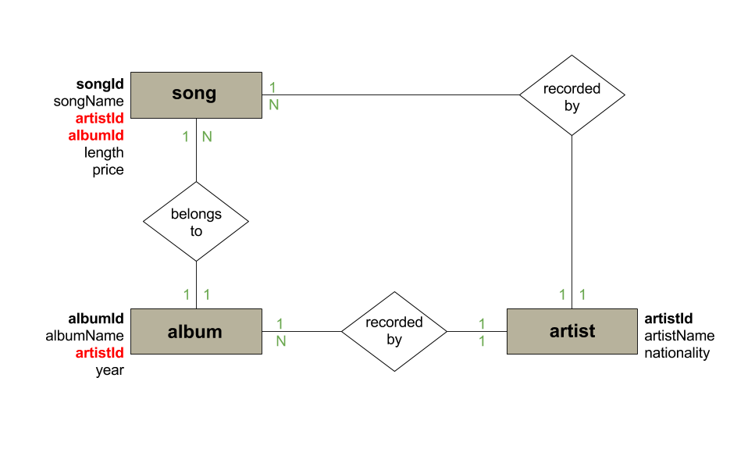

**Mock Up:**

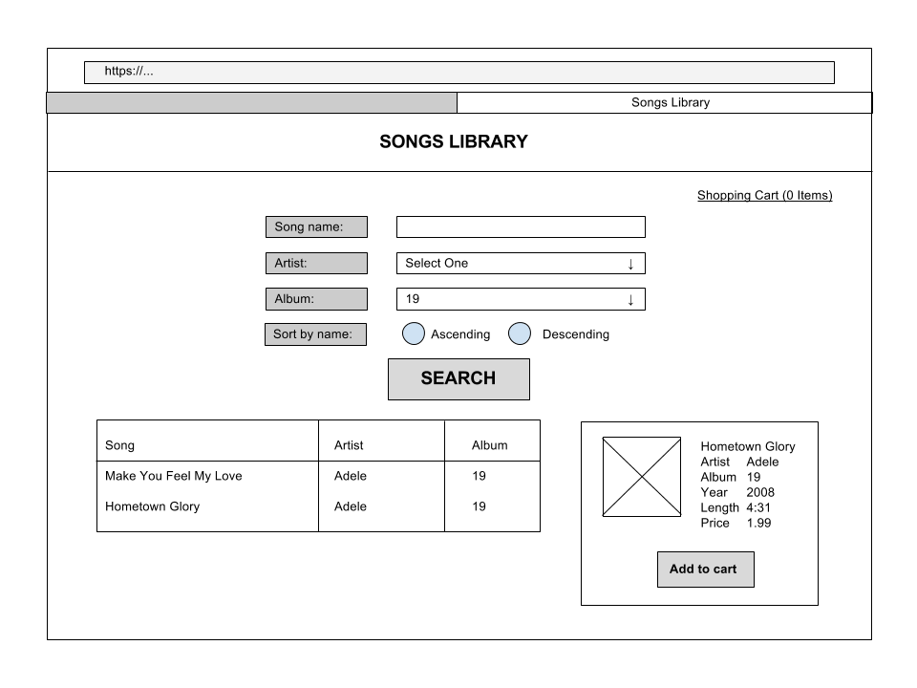

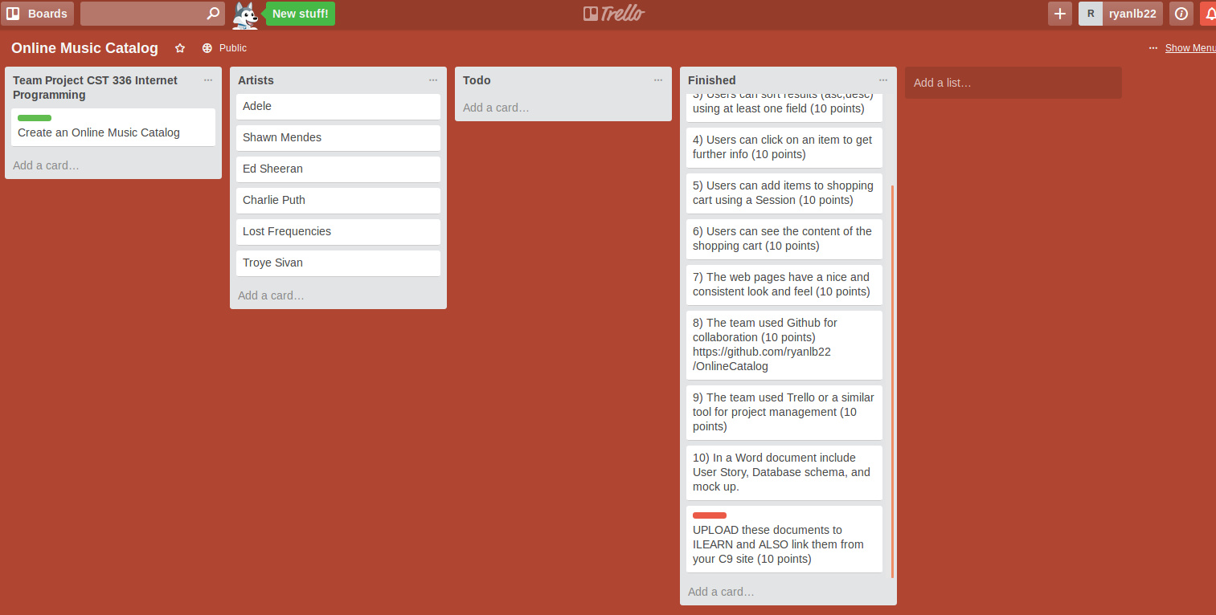Trello Screenshots